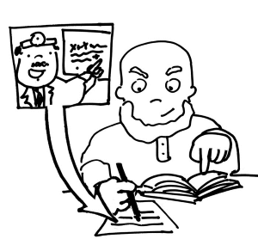

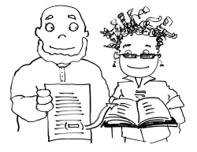

**5 reasons for documenting sources**

You show that your own ideas are supported by experts.

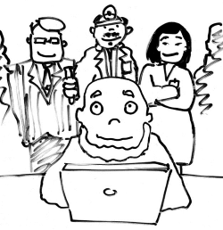

You avoid plagiarism.

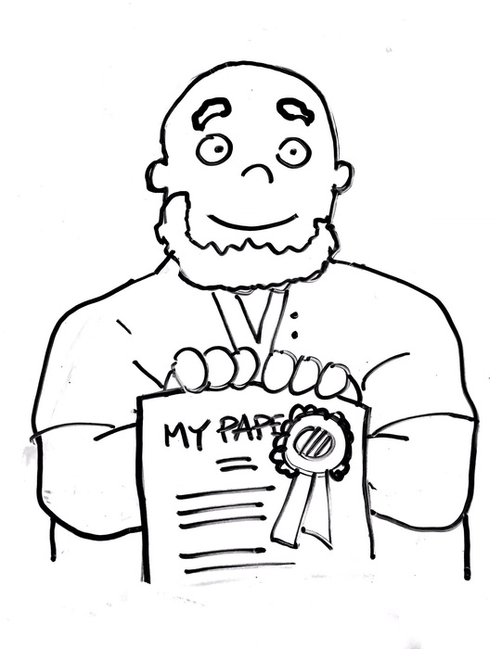

You acknowledge ownership of ideas.

You show off the research and hard work you have done.

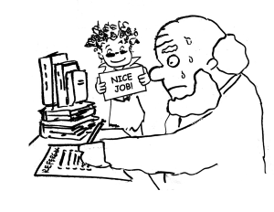

You give your readers a chance to follow up and read more.